IS 350—Prof. Mark G. Simkin Case 2: An Income Tax Return
Spring, 2015 (Draft #2)

The purpose of this case is to practice using Visual Basic programming tools to create a comprehensive tax-preparation application. Thus, you will need to know how to create and manipulate Visual Basic form objects, work with the data in Text boxes, use several Form windows in the same project, and transfer data from one form window to another. This project is more complex than the chapter assignments, so (1) you should plan your time accordingly, (2) work in a team of three people, and (3) start early.

The overall objective of this case is to create a Visual Basic application that helps a user prepare a simplified U.S. income tax return. This task, in turn, involves completing information for Schedules A, B, C, D and E of a return, as well as computing some additional information on a Child Care Worksheet and on Schedule 1040. For convenience, the forms in this project are simplified versions of the IRS forms that you would use to complete a real income tax return.

Main Screen. The starting user interface is the Main Screen (Figure 1), which consists of several Labels, Text boxes, and Radio Buttons, as well as several Buttons. Its purpose is to acquire general information and to allow the user to navigate among the several other supporting forms for the different tax schedules. When the user clicks on any button in this form (except the About or Exit Buttons), the system first ensures there are entries for the user’s name and address, and also a valid social security number and zip code. (Required: use a form-level function for this data validation task that returns a Boolean value of True if the data are valid and false otherwise.) If the user enters a name for his or her spouse, the system also checks that there is a valid social security number for that person. The social security number validation(s) should be performed in a global subroutine. If the data are valid, the system displays the appropriate form (or in the case of the Exit button, ends execution).

Schedule A. When the user clicks on the “Schedule A” Button from the Main Screen, the screen for Schedule A appears (Figure 2). Taxpayers who itemize their deductions must use this form. Note that the Label in Line 8 of this screen appears in italics while the others do not. For this and similar forms, the system should compute values for the Text Boxes with italics Labels, while the user should input information for the Text boxes without such Labels.

In Schedule A, the user enters dollar values for medical and dental expenses, various taxes paid, and so forth. If the user clicks on the “Child Care Worksheet” Button, the system displays the Child Care Worksheet discussed below. If the user clicks on the “Calculate Deductions” Button in this form, the program adds the amounts in the Text boxes, displays this sum in the Text Box in Line 8 (at the bottom of the form), and formats all dollar figures to currency. If the user clicks on the “Main Screen” Button, the system closes the current form and the Main Screen form appears by default. If the user clicks on the Exit button, the system ends execution.

Child Care Worksheet. When the user clicks on the “Child Care Worksheet” in Schedule A, the system displays the form shown in Figure 3. (Hint: use the ShowDialog method to display this worksheet.) This worksheet enables users to determine the allowable child care expenses to deduct in Schedule A. Note that the entries with blue backgrounds for this form—for example, the text entries for the name of the payee(s) and social security number(s) in lines 1 and 2 in this form—are Labels, not Text Boxes. When the user clicks on the label with caption “1” or “2” on the first or second line of this worksheet, the system displays sequential InputBoxes that prompt the user for his or her name (i.e., the “Name of Payee”) and for his or her Social Security Number.

The user must also enter the first name, last name, and qualified expenses paid for each child or dependent in lines 4 and 5 of this form. When the user clicks on one of the entries in the Applicable Percentage frame on the right side of the form and then clicks the “Calculate Allowable Expenses” Button, the system first validates the Social Security Number(s) in lines 1 and 2 of the worksheet. If the number(s) is (are) valid, the system then (1) computes the totals shown on lines 3 and 6, (2) determines the smaller of these two values in line 7, (3) displays the appropriate percentage value in line 8, (4) computes the “Allowable Child Care Expenses” in line 9, and (5) formats the output to currency. When the user clicks the “Return to Schedule A” Button, the system loads the newly-computed value (e.g., $931.70) into TextBox on line 7 of Schedule A. Finally, if the user clicks on the “Exit” Button, the program ends execution.

Schedule B. When the user clicks on “Schedule B” from the Main Screen, the form for Schedule B appears (Figure 4). This is where the user reports the sources and amounts of interest income and dividend income. When the user clicks on the “Calculate Income” Button, the program adds the amounts listed in Parts I and II of this form, and displays these sums in lines 2 and 4. Note that, if the user enters a value for “Excludable Amounts from EE Savings Bonds” for interest income in Part I, the system first subtracts this amount to compute the Reportable Interest Income in line 2 of this form. When the user clicks on the “Main Screen” Button, the system closes the current form and the Main Screen appears by default. Finally, if the user clicks on the Exit Button, the program ends execution.

Schedule C. When the user clicks on “Schedule C” from the Main Screen, the screen for Schedule C appears (Figure 5). This is where the user reports income from a business. This is a multi-part form. The user must enter a business name and business address at the top of the form. The user must also enter beginning and ending inventory (in Part I), gross receipts or sales (Part II), and various types of expenses (Part III). Note that the entries in Part III are optional, meaning a given tax payer might not have any advertising expenses, commissions, and so forth. In short, the user enters data for lines 1, 2, 4, and 7a-7d. When the user clicks on the “Calculate Profit” Button, the program validates the values in the remaining text boxes in this form, and then computes Net Profit using the following calculations:

Line 3 (cost of goods sold) is the difference between beginning inventory (line 1) and ending inventory (line 2). (Note: if the difference is negative, the cost of goods sold is 0.)
Line 6 (gross income) is the difference between gross receipts (line 4) and cost of goods sold (copied from line 3).
Line 8 (total expenses) is the sum of lines 7a, 7b, 7c, and 7d.
Line 9 (net profit) is the difference between gross income (line 6) and total expenses (line 8).

When the user clicks on the “Main Screen” Button, the program closes the current form and displays the Main Screen form by default. Finally, if the user clicks on the Exit Button, the program ends execution.

Schedule D. When the user clicks on the “Schedule D” button in the Main form, the program displays Schedule D (Figure 6). Taxpayers use this form to report short- and long-term capital gains—e.g., the profits made or losses incurred on the ownership of stocks and bonds. Short-term capital gains are for assets held one year or less. Long-term capital gains are for assets held more than one year. Users must input the purchase date, sales date, sales price, and cost basis of each asset reported here. There is also room for tax payers to include both short-term and long-term loss carryovers from prior years.

When the user clicks on the Calculate Button, the system validates the numeric portion of the entries and computes net short- and long-term gains or losses. When the user clicks on the Main Screen Button, the system closes Schedule D and the Main Screen appears by default. Finally, if the user clicks on the Exit Button, the system ends execution.

Schedule E. When the user clicks on the “Schedule E” button in the Main form, the program displays Schedule E (Figure 7). Taxpayers use this form to report rental income on properties they own. Users must indicate the address of each property, plus the income and various expenses for each one. The Subtotals row shows the gross profit for each property, which equals the income minus the sum of the expenses. The user must list the depreciation for each property separately in the Depreciation row, and the Grand Totals row shows the difference between the Subtotals and the Depreciation. As indicated here, values can be negative. The final three rows of the form are self-explanatory. When the user clicks the Calculate button, the system computes the gross profit for each property, as well as the values for each of the final three rows of the form, and formats all numeric values to currency as shown in Figure 7. The only data validations required here are: (1) all rents received must be positive numeric values, and (2) all properties listed must have rental income. When the user clicks on the Main Screen button, the Schedule E screen closes, and the system displays the Main Screen button by default. Finally, if the user clicks on the Exit Button, the system ends execution.

Form 1040. When the user clicks on the “Form 1040” Button in the Main form, the program displays this form (Figure 8). This is a summary form that shows the totals from the other forms. Thus, the system should initialize the values for lines 3, 4, 5, 6, and 7 (from Schedules A, B, C, and D) when this form loads. Note that the user’s name (e.g., “Mark G. Simkin”) appears in the caption of the group box at the top of this form, along with the taxpayer’s filing status (e.g., “single”).

If the user clicks on the Calculate Tax Button in this form, the system computes the total tax owed. This “Computed Tax” on line 13 of this form depends upon the tax payer’s filing status. For simplicity, please use the rates in the following table for these computations. The term “Total Taxes Withheld” on line 14 is the total amount the user paid in taxes (a value the user must enter in the form). Line 15 is the difference between line 13 and line 14. If the amount is negative, this means that the IRS owes the user a refund and the Label for Line 14 should display the term “Refund” instead of “This is the Amount You Owe.” The dollar amount in the textbox for line 15 should always be positive.

Income Range: | Single or Married/Separate |  |  | Married/ Joint |  | Head of Household or Widower
Less than 10,000.99 |  | 0.100 | 0.100 |  | 0.100
10,001 to 25,000.99 |  | 0.150 | 0.160 |  | 0.145
25,001 to 90,000.99 |  | 0.180 | 0.195 |  | 0.175
90,001 to 130,000.99 |  | 0.280 | 0.255 |  | 0.245
130,001 or more |  | 0.310 | 0.340 |  | 0.365

If the user clicks on the “Print Summary” button on Form 1040, the system prints a summary of the 1040 information, using the suggested format shown in Figure 9. Please (1) use the name of your own company for the software company name at the top, (2) your own slogan in the heading, and (3) the system date (Today) for the date of the printing. Note that the decimals in the line numbers align vertically. You can obtain new colors for the heading using different settings for the “brushes” parameter in your print routine instructions. All figures should be right aligned, but dollar signs for your numbers are not required.

Credit Card Payment Screen. If the user clicks on the Credit Card radio button in Form 1040 (indicating a preference to pay by credit card), the application displays the user interface in Figure 10. Here, the user selects a particular card type (= American Express, Discover, MasterCard, or Visa), inputs his or her credit card number, and inputs the expiration month and year of the card. When the user clicks the OK button, the system verifies that all three inputs were made, validates that the credit card has 16 digits and includes dashes in the form 9999-9999-9999-9999 (where 9 is any digit and the dashes are present), and that the expiration month is between 1 and 12.

The system also verifies the validity of the user’s credit card number by computing a special check digit and comparing that digit to the month code. The algorithm works as follows. First, the system strips the dashes from the credit card (Hint: use then Replace function). Next, it adds the digits in the credit card, takes the low order digit in this sum, and uses it as a check digit. The month code is the same as the expiration month if it is 9 or less. If the month is “10,” the month code is “1”, if the month is “11” the month code is “2”, and if the month code is “12,” the month code is “3.”) If the check digit matches the month code, the system concludes that the credit card is valid. If not, the system provides a message box (Figure 11) indicating the error. For example, if the credit card number were 1234-5678-9012-1234, the sum of these digits is “58” and the check digit is “8.” This would not match the month of “12” shown in Figure 10, whose month code is “3.”

General Project Requirements. Your group should agree on a color scheme for your work other than the one shown here, and develop all screens consistently using those colors. You should also make sure that (1) your forms display the proper banner texts (e.g., “Form 1040”) as shown in the forms here, (2) your code uses the naming conventions discussed in class for your form objects, and (3) you use comments to adequately document your code. You should also right-adjust all dollar figures in the Text boxes and format them as currency.

This is a large project, but the quality of your work will not be appreciated if you do not document it carefully. Thus, you should be very meticulous because you will not get credit for missing or poorly-documented work. Your project should also contain validation tests that disallow faulty data as follows:

For Schedules A, B, C, and D, use the click procedure for the “Calculate” Button to perform the data validation tests summarized below. If an entry in a form violates one or more of the requirements listed above, the program should (1) display a Message Box indicating the type of error (e.g., “Wages must be more than $1” in Form 1040), (2) not perform any calculations, and (3) return the focus to the appropriate TextBox for user correction. Finally, note that all Buttons in this project have access keys.

Form Line(s) Requirement
Main Screen 1, 2 Each Social Security Number, if entered, should contain exactly 9 numeric digits in the form xxx-xx-xxxx where x is an integer.*
1, 3, 4 Each text box in these lines cannot be blank.
4 The zip code must contain exactly 5 numeric digits.
1040 2 Wages must be must be more than $1.00 and no more than $500,000.
11 Tax payments must be positive.
Child Care 1, 2 Each Social Security Number, if entered, should contain exactly 9 numeric digits in the form xxx-xx- xxxx, where x is an integer.*
Schedule A (all) All numeric entries (if made) must be non-negative numbers**
Schedule B (all) All numeric entries (if made) must be non-negative numbers**
Schedule C (all) All numeric entries (if made) must be non-negative numbers**
Schedule D (all) All numeric entries (if made) must be non-negative numbers**
Schedule E rents All rents received must be positive numeric values, and all properties with addresses must have rents

*Tested with a global subroutine
**Tested with a global function. Hint: blanks are acceptable but negative numbers are not.

Deliverables:

- Test Data. Test your program with the test data provided by your instructor. For each set of data, you should print a complete set of screen captures, in color, that show the computed values. Please also include a hard copy printout of your Form 1040 Summary sheet (Figure 8). Collect these materials together, organized by case, and label them “Test Data” on a tab page in your binder.

- Technical Documentation. Create both internal and external documentation that describe your program in sufficient detail to allow someone else to understand it and maintain your code. To do this and for each screen, print exemplary copies of all form images (at run time) as well as the code for all forms in this assignment, including an About form (Figure A). You may print more than one form image on a page, but all code should be clearly identified so that the reader knows what code corresponds to what procedure in what form. Please include the code for your module(s) but omit any system-generated code. Collect this set of pages together and label it “Technical Documentation” on a separate tab page in your binder.

- User Manual. The programmers who create a project are rarely the end users. Thus, you must also create a user manual that helps non-technical individuals use your application. This (small) manual should include a general introduction and a description of what each Button in each form does (see pages 1-3 above). A (small) screen capture of each screen should appear on the same page that it is discussed. Use your own screen captures with the name of one of your group members for this—not the ones included here. Collect this external documentation for your project together and label it “User Manual.”

- Enhancements. This is your chance to be creative. Develop an enhancement for this project that uses an additional form. An example might be an additional income tax schedule or supporting worksheet (it doesn’t have to be overly complicated). This work should be original: you may not use any of your prior homework applications as enhancements or the form for an About button. Documentation for your enhancement is critical. Thus, you should provide a screen capture of your form at run time, the code for each procedure in your enhancement, and a complete description of what your enhancement does in one or more separate pages. Collect these pages together and label them “Enhancement.” (Note: a simple form with just a few form objects and a single “OK” button, or an enhancement lacking prose descriptions will not receive full credit.)

Publication. Combine the complete set of items described above in a small, 3-ring binder, complete with dividers identifying each part of your project. Other publication requirements are as follows:

  - The first, title page should contain the title of this project and the full names of the developers in your group, along with pictures of each member, and an indication of who did what tasks.
  - The first page after your title page should be a detailed table of contents that indicates the starting page of each major section. Each subsequent page should be numbered.
  - Your work should be printed on single-sided copy, in color, using a 12-point font.
  - Finally, use tabs to separate each of the major sections of your report, which should appear in the order shown above (i.e., starting with Part A and ending with Part D).

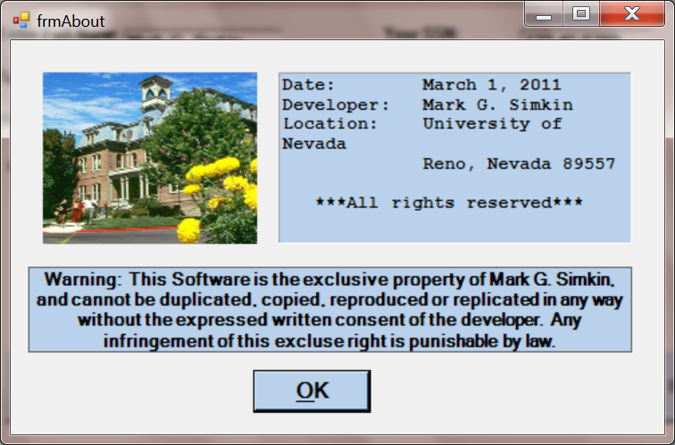
Figure A An example of an About form

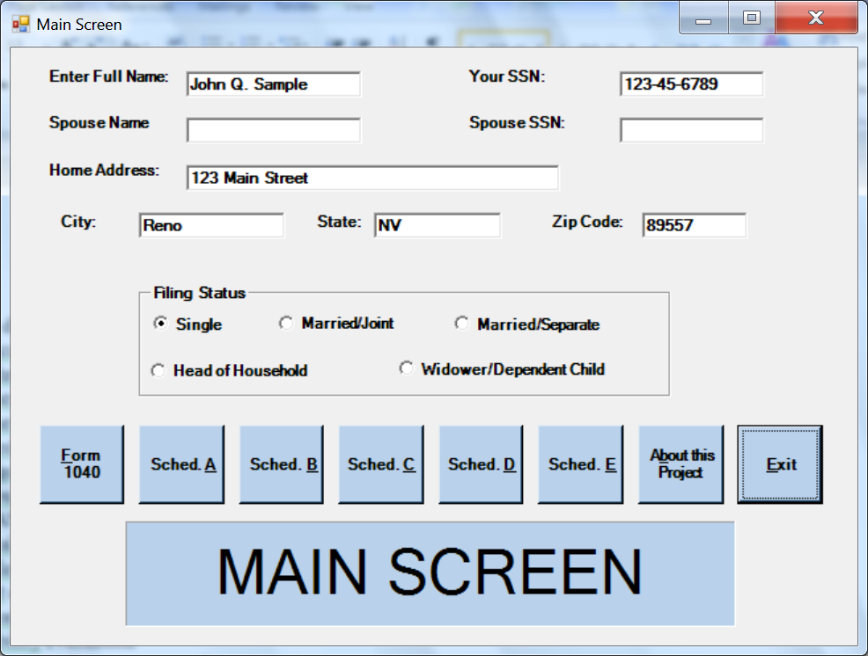

Figure 1 Main Screen for Application

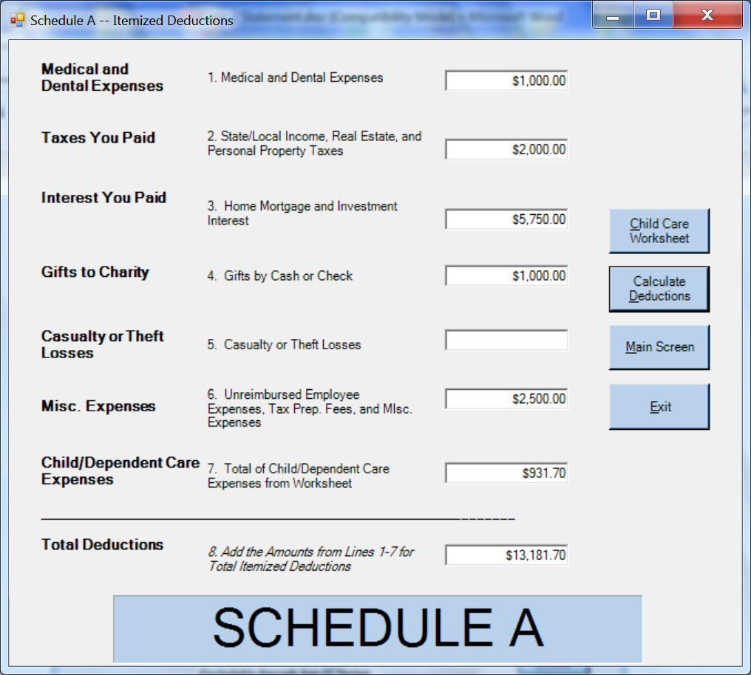

Figure 2 Schedule A

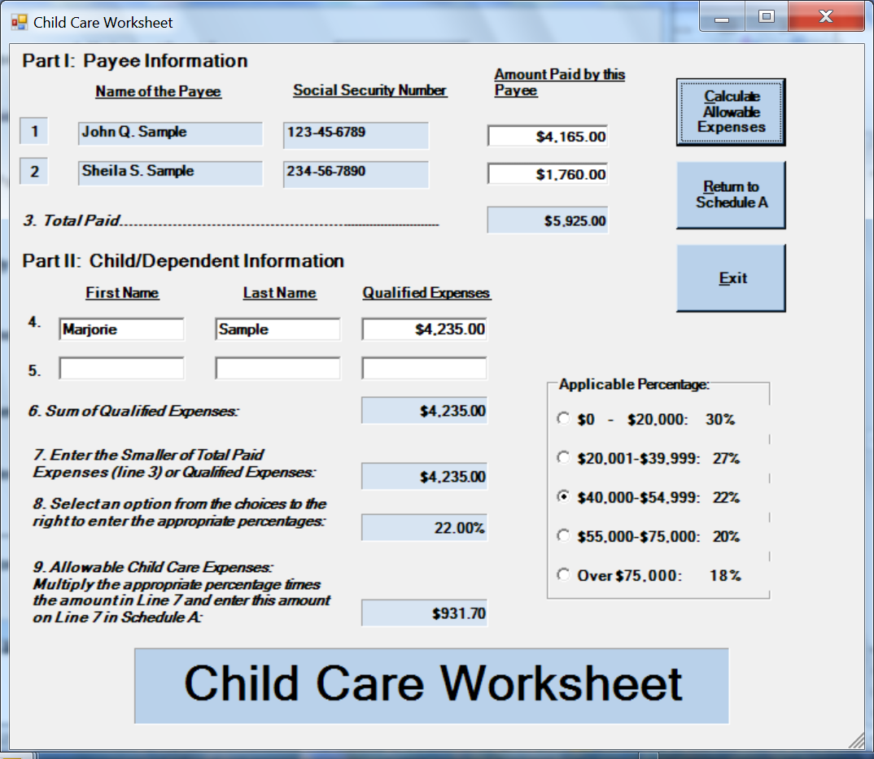

Figure 3 Child Care Worksheet

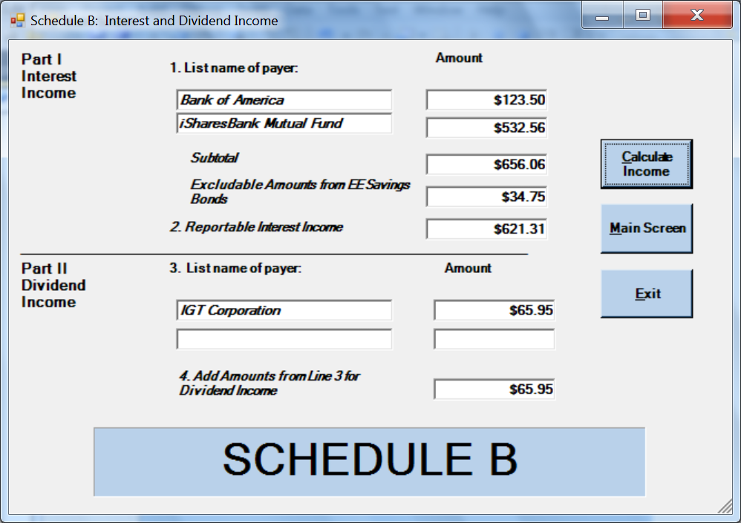

Figure 4 Schedule B

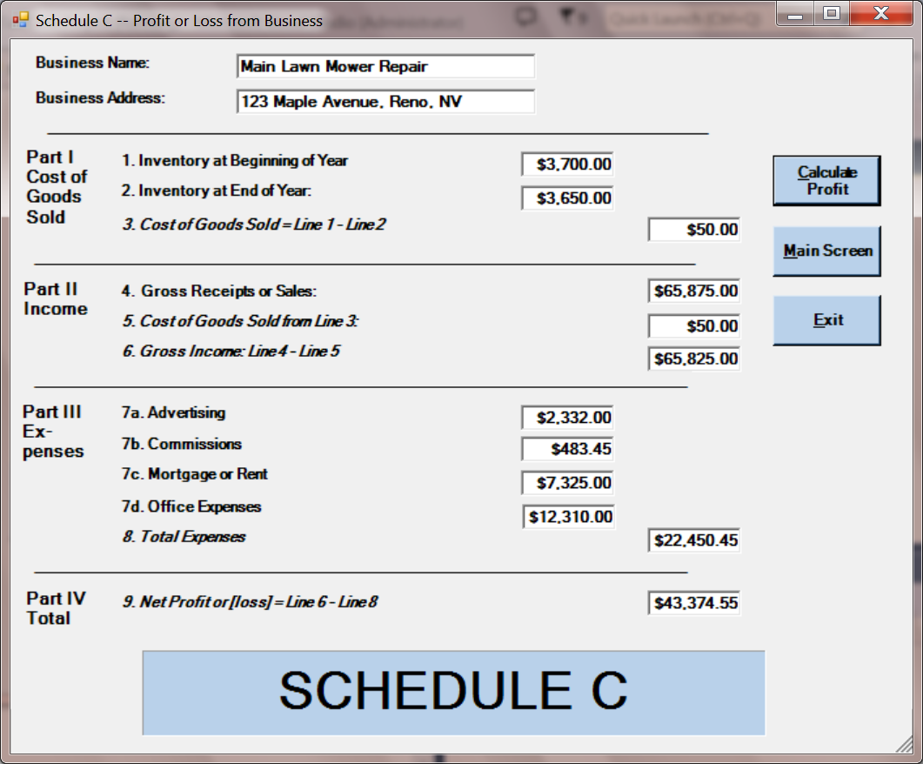
+

Figure 5 Schedule C

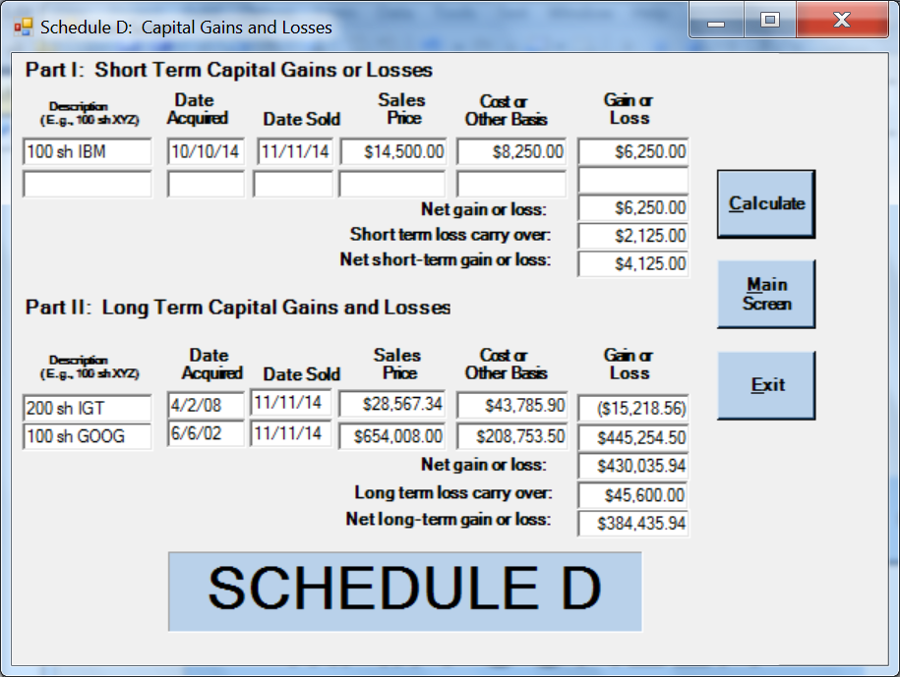
Figure 6 Schedule D

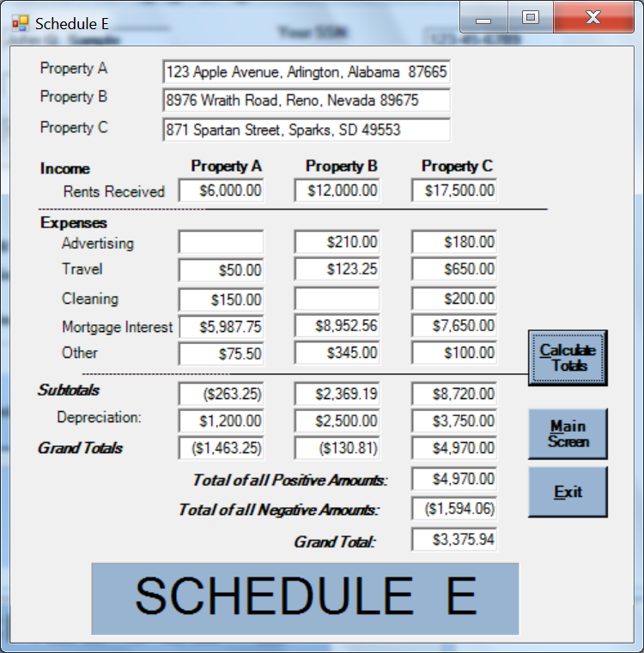
Figure 7 Schedule E

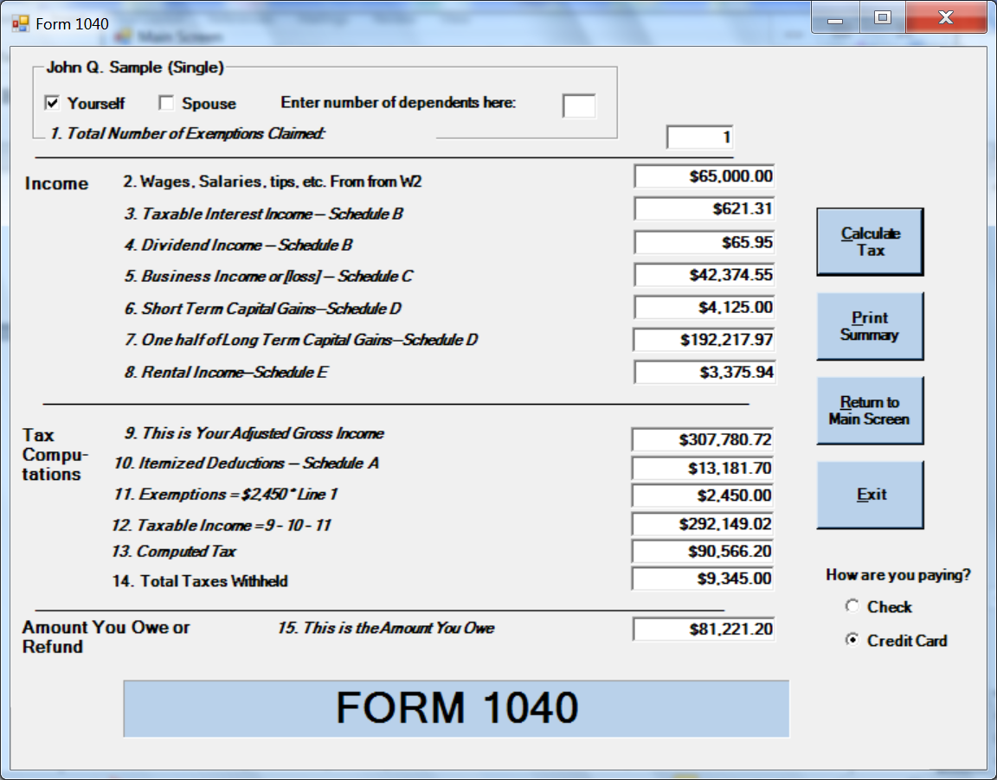

Figure 8 Form 1040

MGS Software
“Taxes for the Masses”

Income Tax Return for: John Q. Sample
Date: 4/15/2015
Number of Exemptions: 1

Income
2. Wages, salaries, tips, etc. | 65,000.00
3. Taxable interest (Schedule B) | 621.31
4. Dividend income (Schedule B) | 65.95
5. Business income or loss (Schedule C) | 42,374.55
6. Short-term capital gains (Schedule D) | 4,125.00
7. One half long term capital gains (Schedule D) | 192,217.97
8. Rental Income | 3,375.94
Total adjusted gross income |  | 307,780.72
9. Itemized Deductions (Schedule A) | 13,181.70
10. Exemptions | 2,450.00
11. Taxable income |  | 292,149.02
12. Computed tax |  | 90,566.20
13. Total taxes withheld |  | 9,345.00
Amount owed |  | 81,221.20

Figure 9: Format for printing a summary of the information in Form 1040.

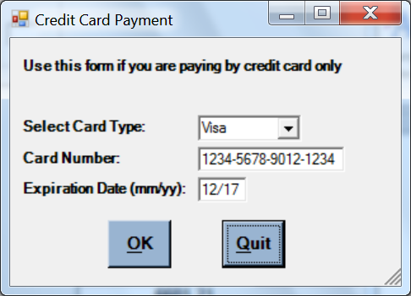

Figure 10: The user interface for a credit card payment.

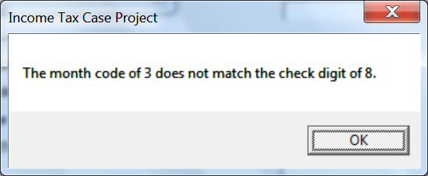

Figure 11: The error message that occurs when the month code and check digit do not match.

